Assignment 5
PNR: 260740150018
Name: PRATIK SUNIL ABHANG

Question:
Write a menu driven program to create set and dictionary

Program
def menu():
my_set = set()
my_dict = {}
while True:
print("\n1. Add to Set")
print("2. Add to Dictionary")
print("3. Display Set")
print("4. Display Dictionary")
print("5. Exit")
choice = input("Enter your choice: ")
if choice == "1":
value = input("Enter value: ")
my_set.add(value)
elif choice == "2":
key = input("Enter key: ")
value = input("Enter value: ")
my_dict[key] = value
elif choice == "3":
print("Set:", my_set)
elif choice == "4":
print("Dictionary:", my_dict)
elif choice == "5":
break
else:
print("Invalid choice")
menu()
Input and Output
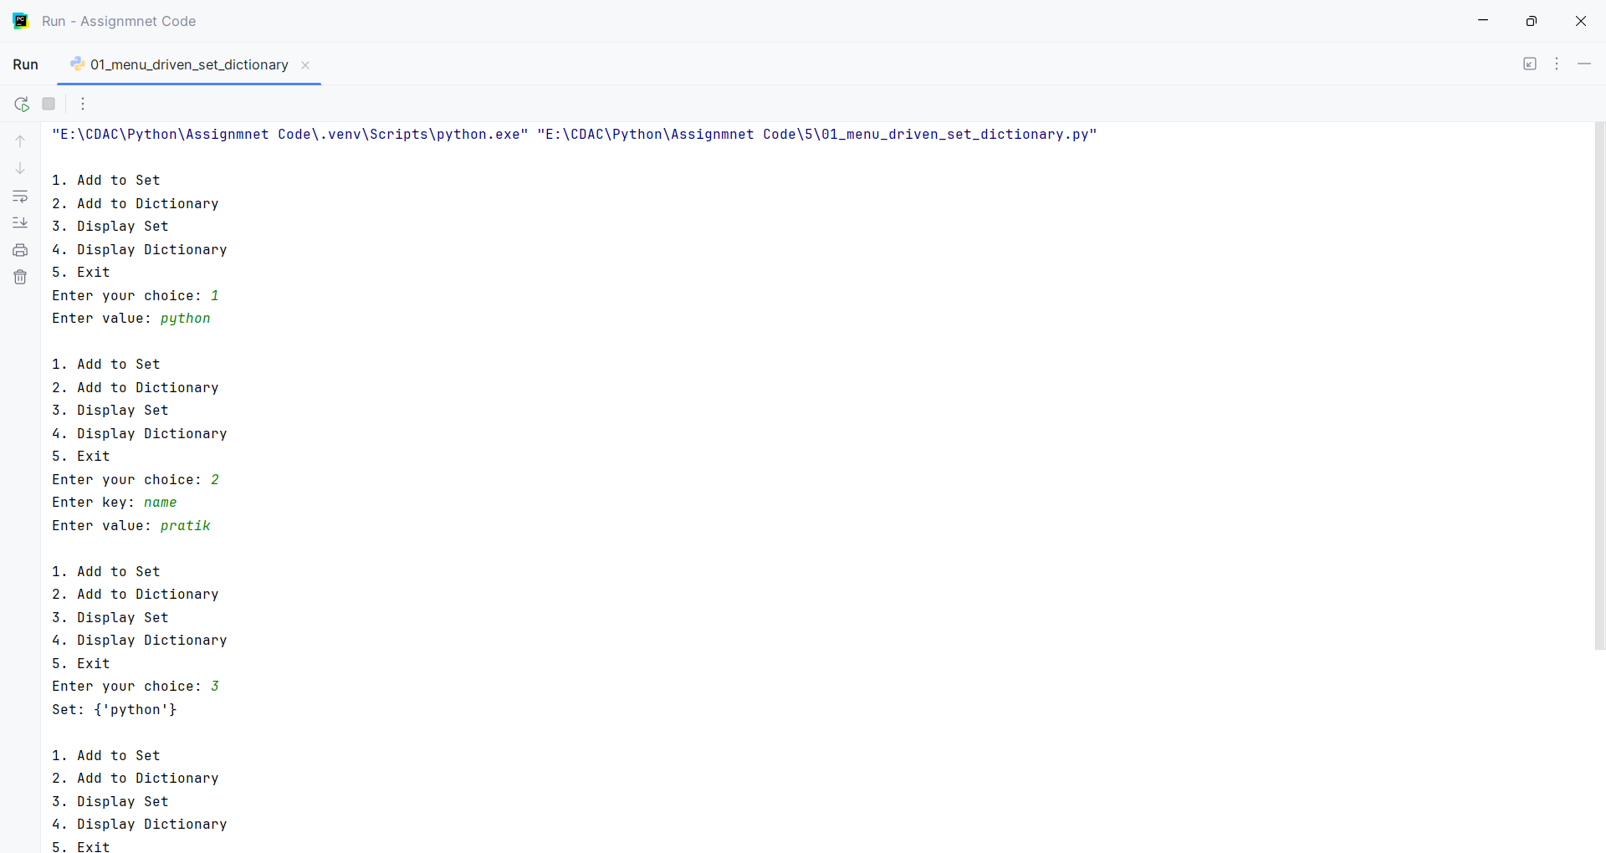
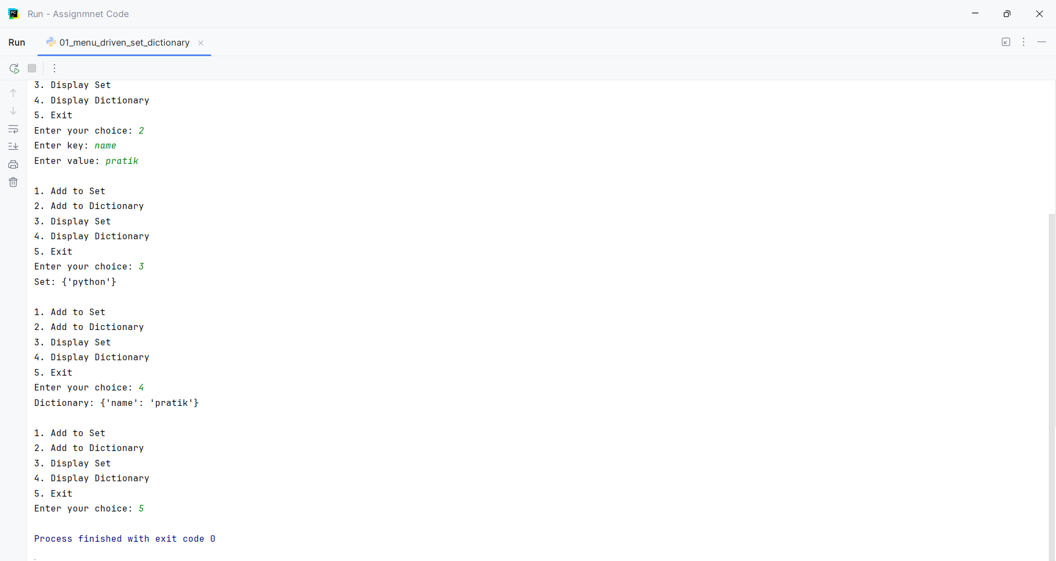

Question:
Write a program to count the number of characters and lines in a file

Program
def count_file():
file_name = input("Enter file path name: ")
with open(file_name, "r") as file:
data = file.read()
print("Number of characters:", len(data))
print("Number of lines:", len(data.splitlines()))
count_file()

Input and Output
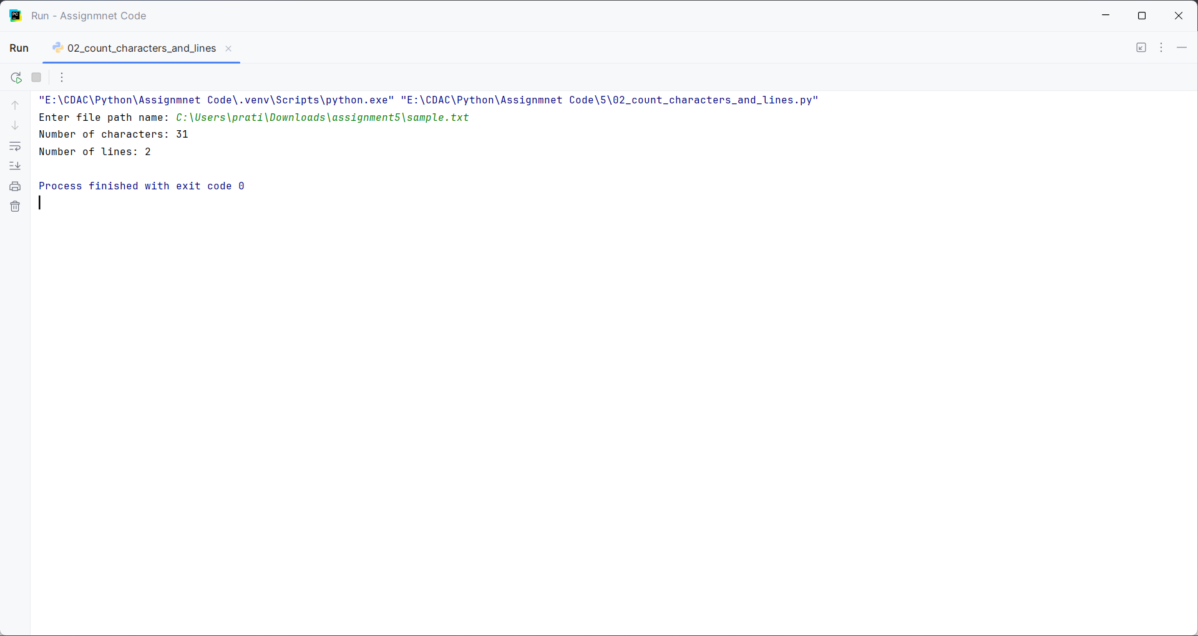

Question:
Revise file and directory creation

Program
import os
def create_file_directory():
folder = input("Enter folder name: ")
file_name = input("Enter file name: ")
os.makedirs(folder, exist_ok=True)
path = os.path.join(folder, file_name)
with open(path, "w") as file:
file.write("Hello")
print("Directory created:", folder)
print("File created:", path)
create_file_directory()

Input and Output
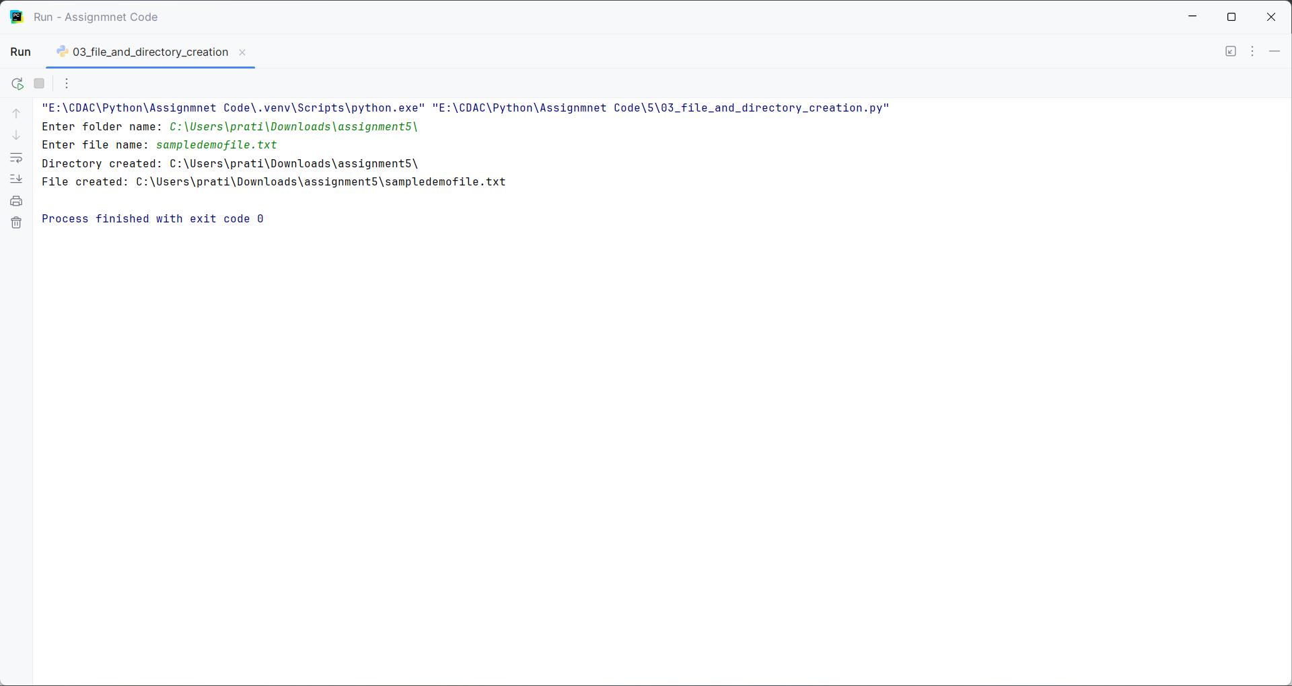

Question:
Revise : Self Learning
Key word arguments

Program
def student(name, age):
print("Name:", name)
print("Age:", age)
name = input("Enter name: ")
age = int(input("Enter age: "))
student(age=age, name=name)

Input and Output
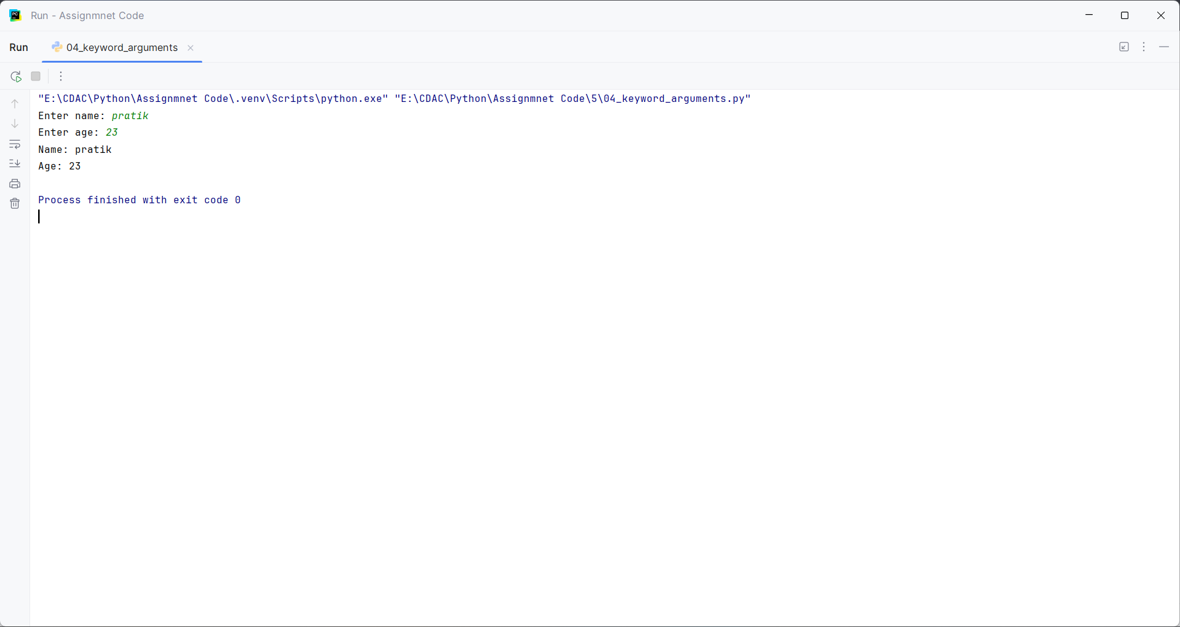

Question:
Revise : Self Learning
Positiinal argument

Program
def student(name, age):
print("Name:", name)
print("Age:", age)
name = input("Enter name: ")
age = int(input("Enter age: "))
student(name, age)

Input and Output
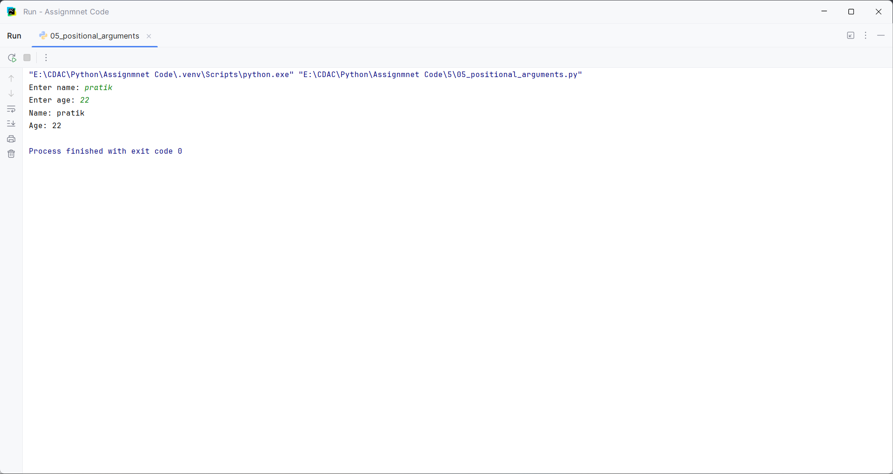

Question:
Revise : Self Learning
Anonymous function

Program
def anonymous_function():
number = int(input("Enter a number: "))
square = lambda x: x * x
print("Square:", square(number))
anonymous_function()

Input and Output
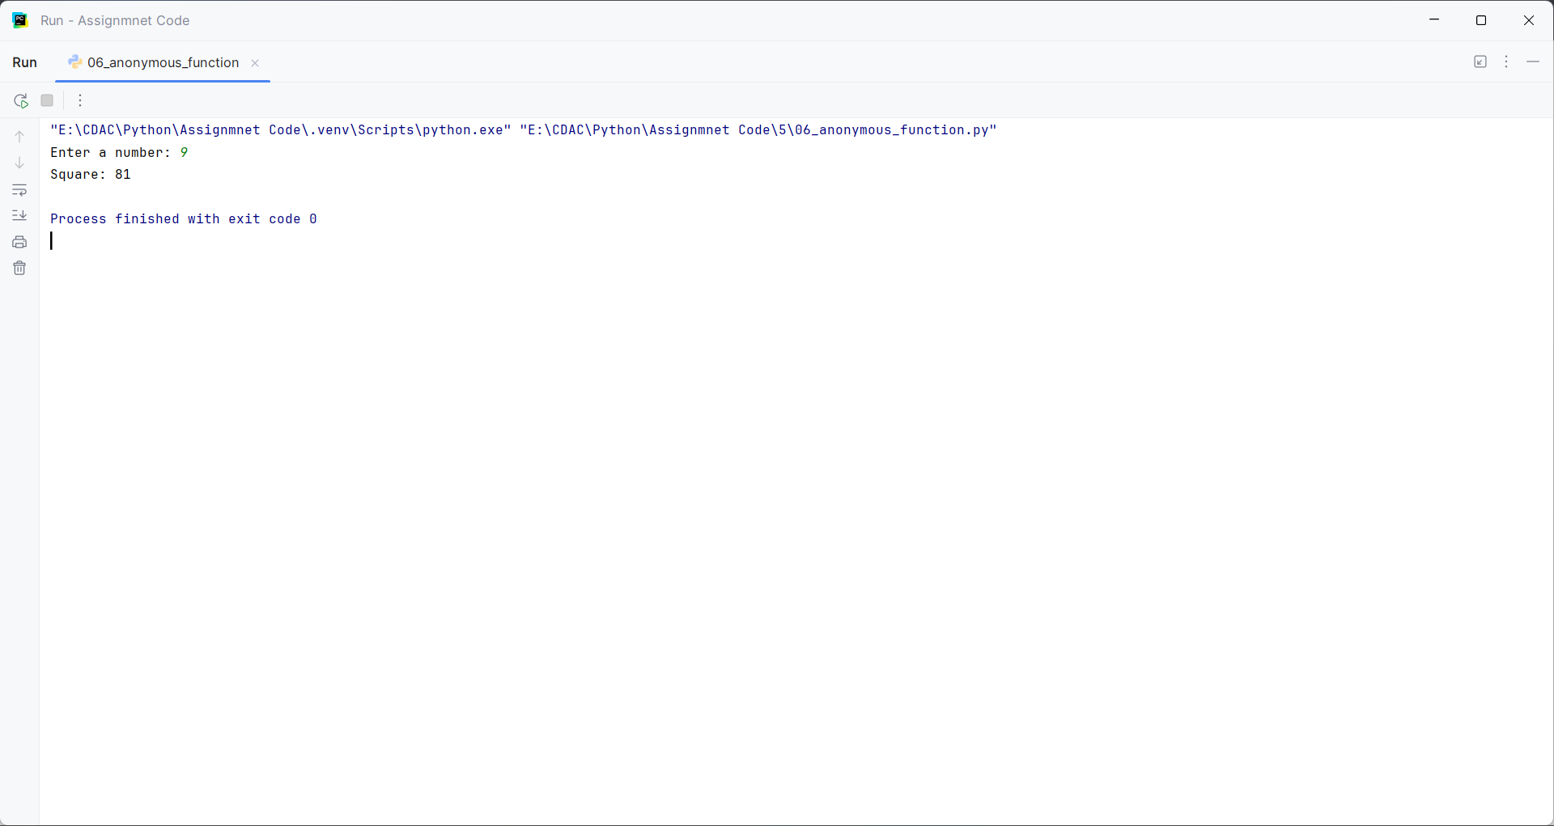

Question:
Revise : Self Learning
Generator

Program
def numbers(n):
for i in range(1, n + 1):
yield i
n = int(input("Enter a number: "))
for value in numbers(n):
print(value)

Input and Output
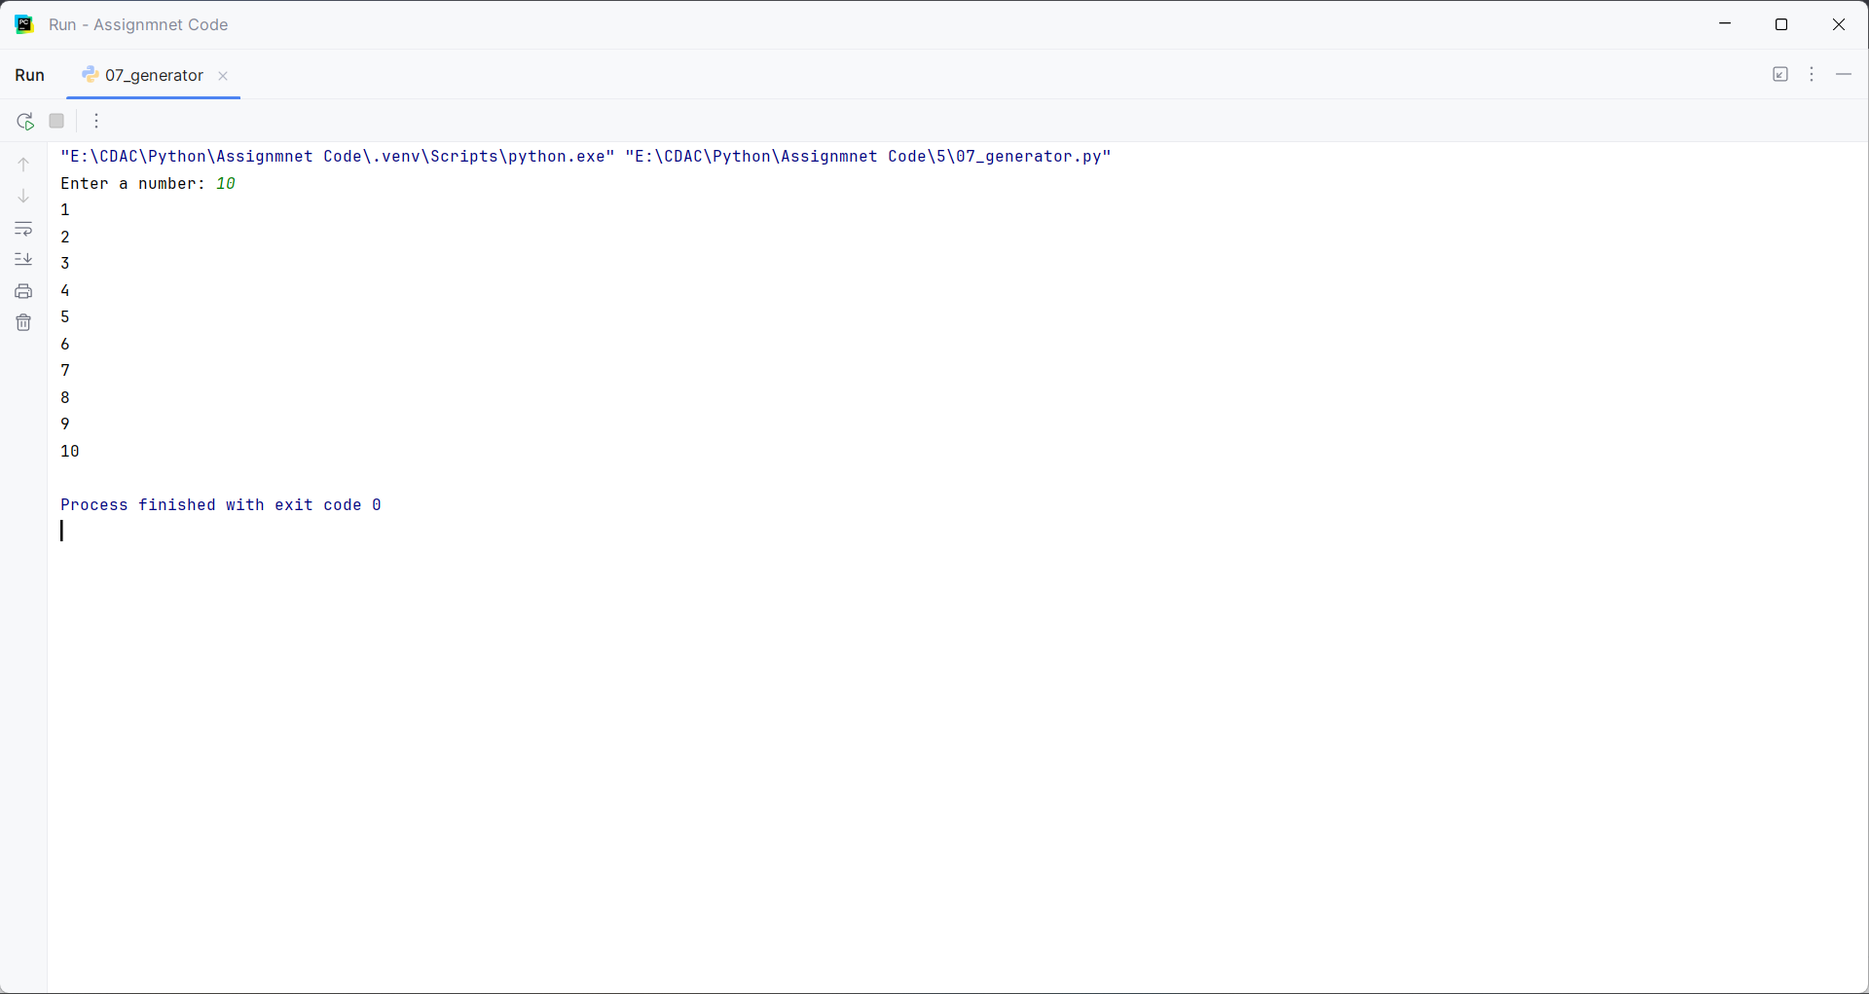

Question:
Revise : Self Learning
Iterator

Program
def iterator_example():
text = input("Enter a word: ")
it = iter(text)
print(next(it))
print(next(it))
iterator_example()

Input and Output
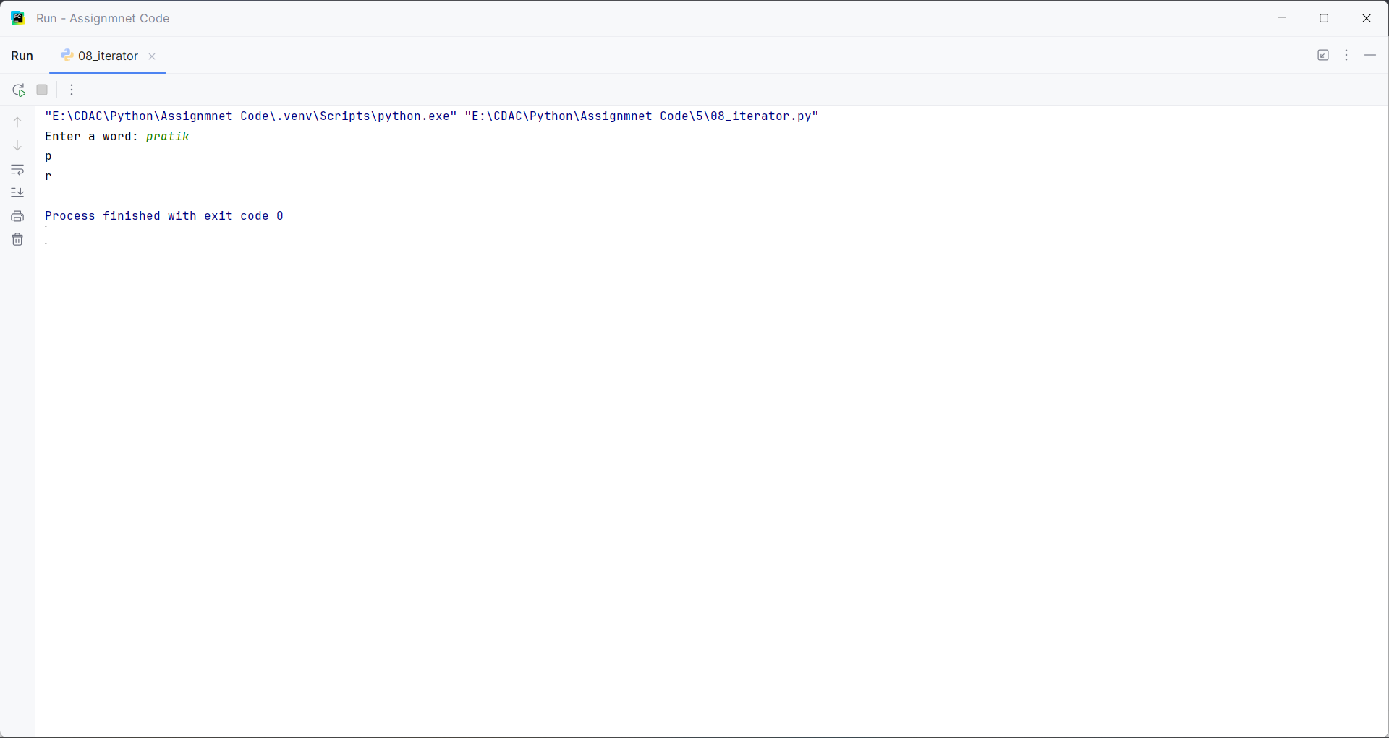

Question:
Revise : Self Learning
Nested function

Program
def outer():
name = input("Enter your name: ")
def inner():
print("Hello", name)
inner()
outer()

Input and Output
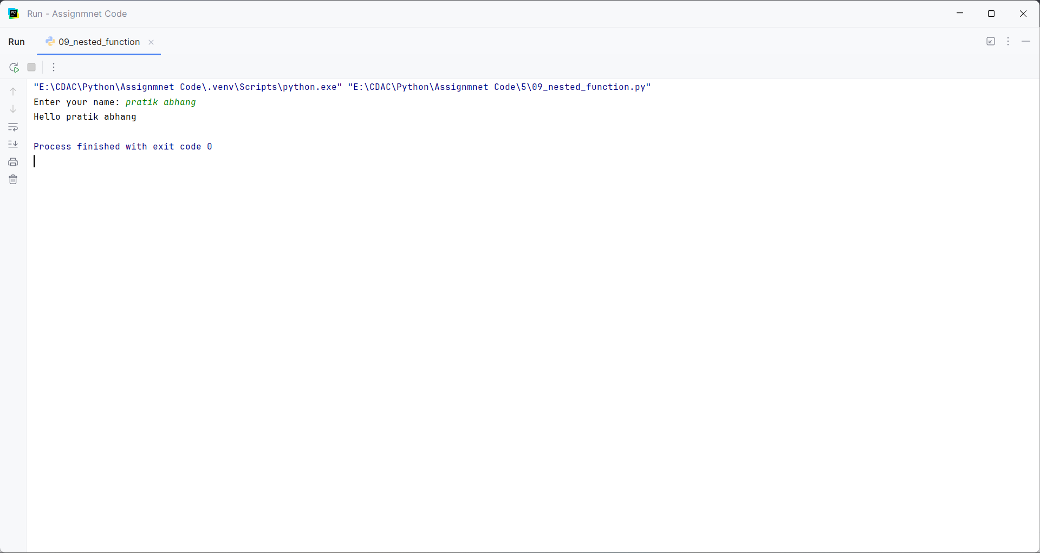

Question:
Revise : Self Learning
Loops and nested loops

Program
def loops():
n = int(input("Enter a number: "))
print("Loop:")
for i in range(1, n + 1):
print(i)
print("Nested Loop:")
for i in range(1, n + 1):
for j in range(1, i + 1):
print("*", end="")
print()
loops()

Input and Output
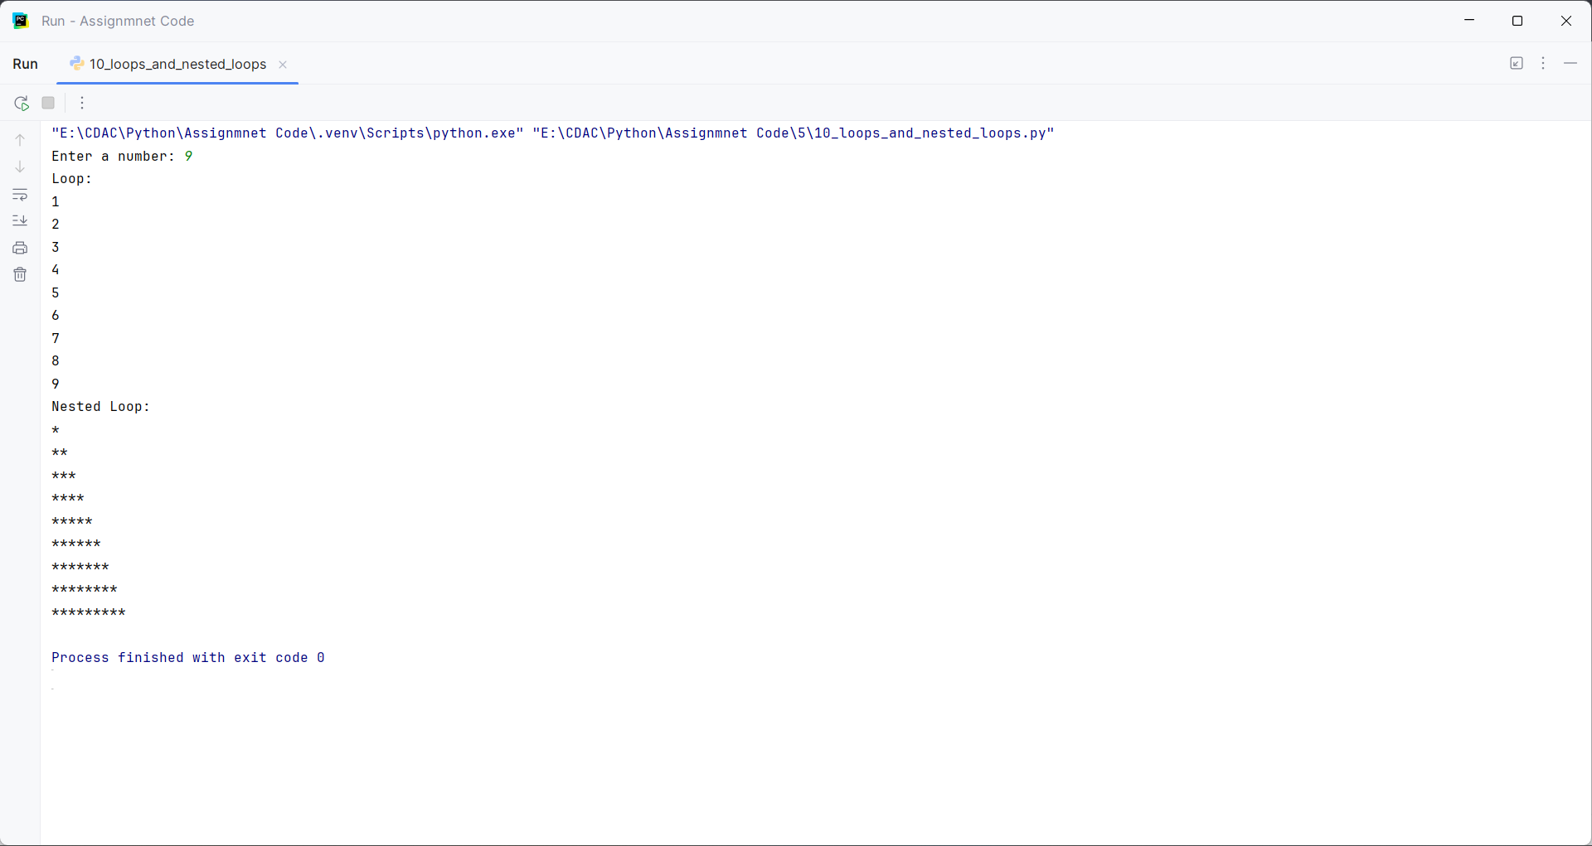

Question:
Revise : Self Learning
Functions return multiple values

Program
def calculate(a, b):
return a + b, a - b
a = int(input("Enter first number: "))
b = int(input("Enter second number: "))
sum_value, difference = calculate(a, b)
print("Sum:", sum_value)
print("Difference:", difference)

Input and Output
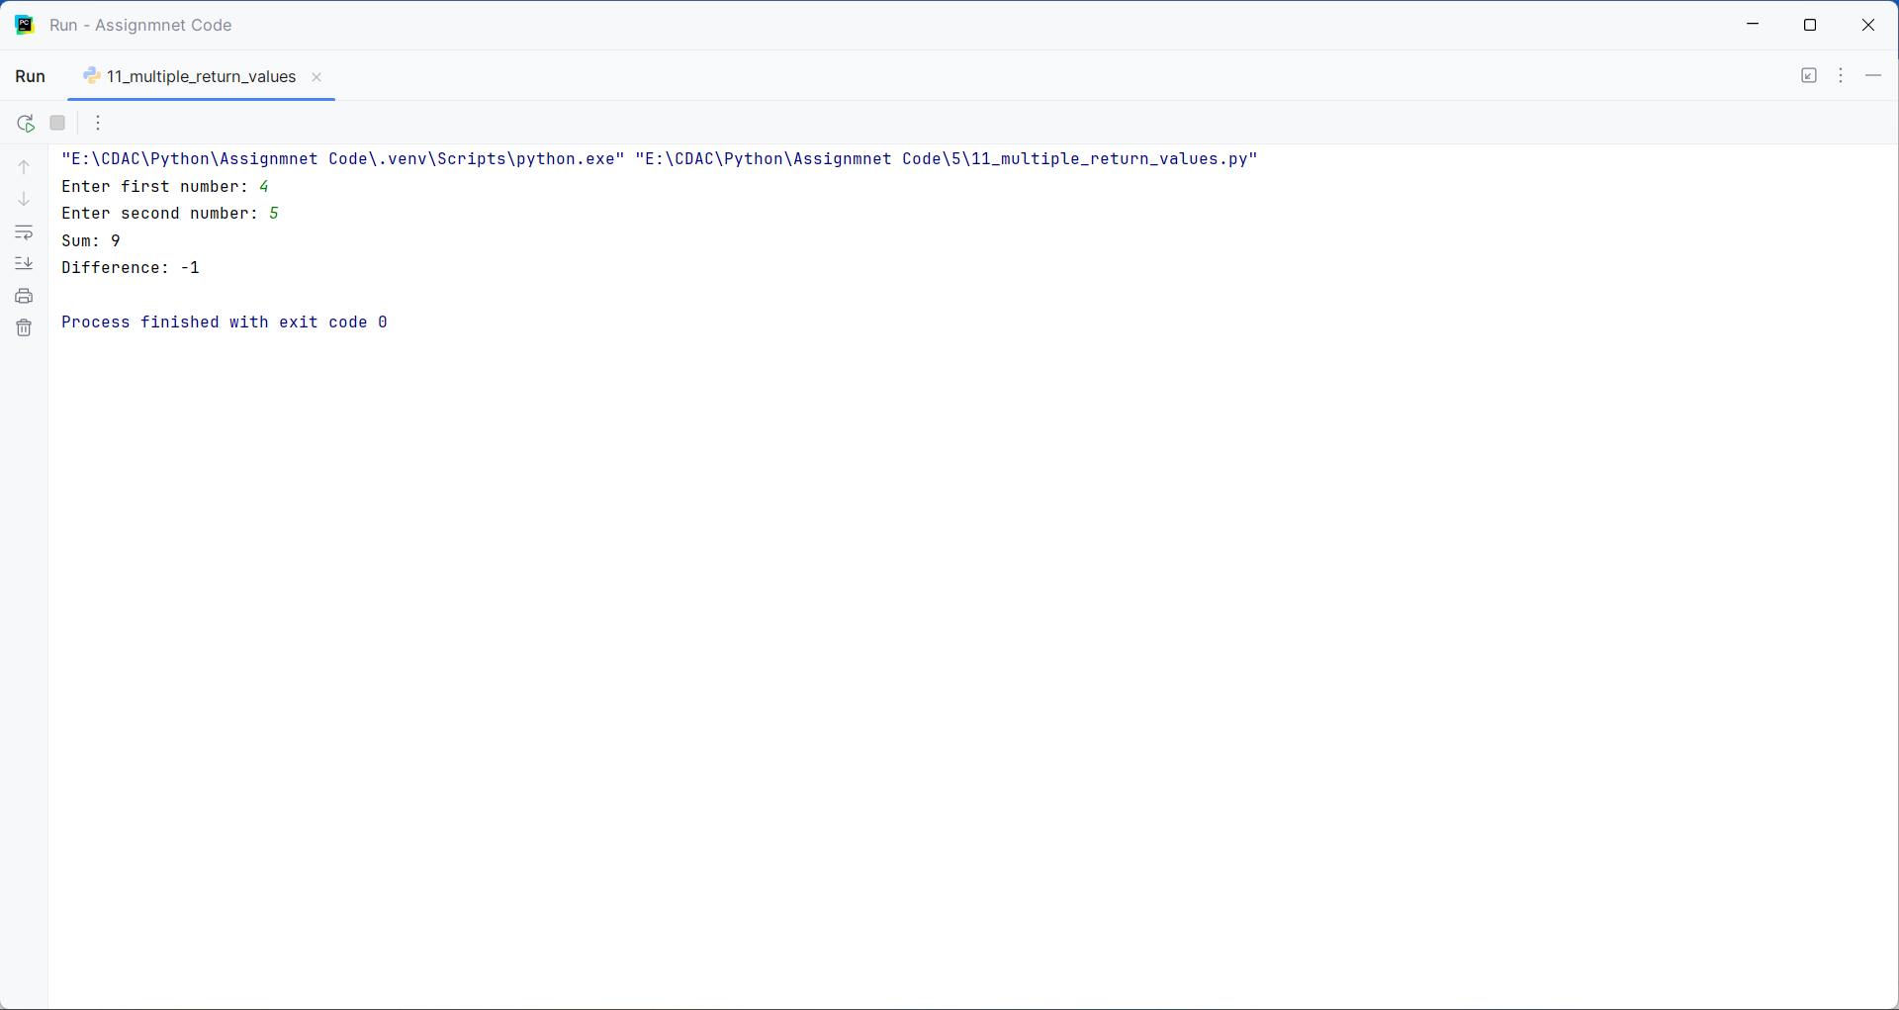

Question:
Revise : Self Learning
Local and global with functions

Program
number = 10
def show_local():
number = 20
print("Local number:", number)
def show_global():
global number
number = 30
print("Global number:", number)
show_local()
print("Outside function:", number)
show_global()
print("Outside function:", number)

Input and Output

